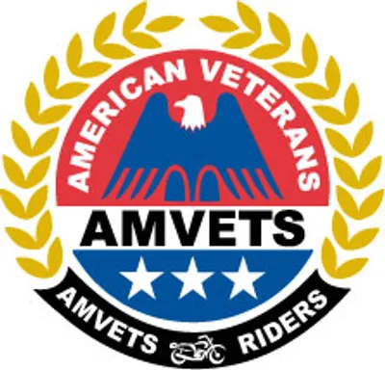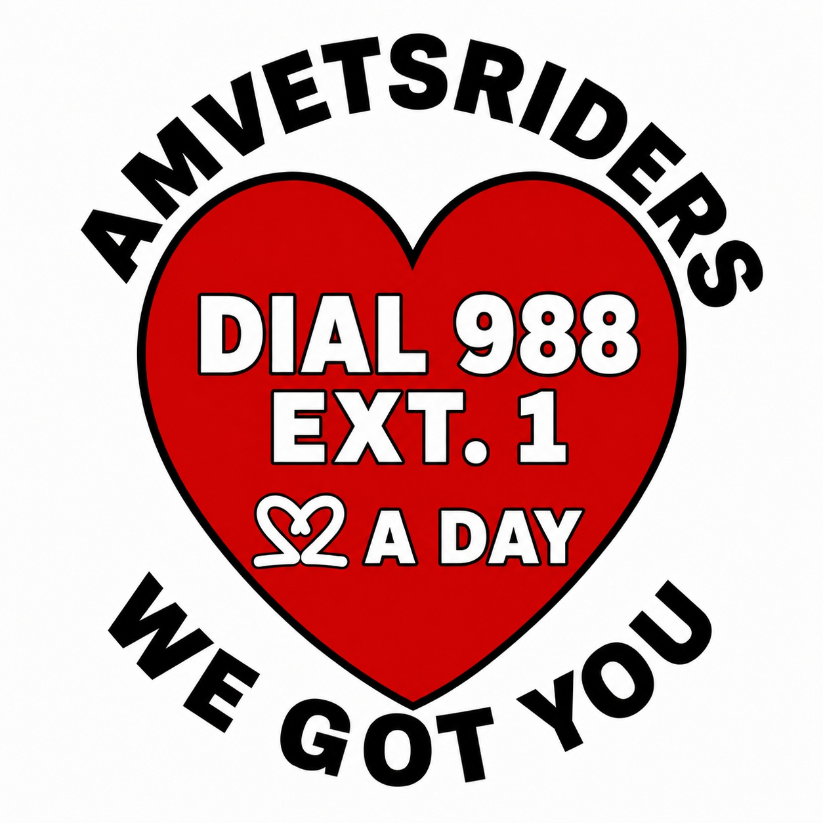
AMVETS RIDERS
WE GOT YOU
DIGITAL FORMS PACKAGE
All 16 forms referenced in the WE GOT YOU Program Manual, ready to fill in Word, customize with your Chapter letterhead, and print.
To fill in Word, click into any blank ruled line and type. The underline stays in place as you type over it.

[ ADD YOUR CHAPTER NAME / NUMBER HERE ]
WE GOT YOU • AMVETS Riders Veteran Wellness Program
Form 1
Help Request Form
Reference: Module 7; Veteran Relief Intake
Date | Intake Taken By
Veteran Name |  | Branch of Service / Era
Phone | Email / Alternate Contact
Emergency? ☐ Yes ☐ No
Any indication of risk of self harm? ☐ Yes; STOP and follow the Module 5 protocol now ☐ No
Nature of Request

Referred By | Follow up Date
Immediate Action Taken

[ ADD YOUR CHAPTER NAME / NUMBER HERE ]
WE GOT YOU • AMVETS Riders Veteran Wellness Program
Form 2
Financial Assistance Request Form
Reference: Module 3; Chapter Relief Fund
Veteran Name |  | Date
Amount Requested | Category (Housing, Utility, Food, Medical, Gas Assistance, Other)
Documentation attached? ☐ Yes ☐ No
Describe documentation (shutoff notice, eviction notice, invoice, etc.)

Pay directly to vendor? ☐ Yes ☐ No; explain below
Vendor Name (if applicable) | Vendor Account/Invoice #
Requested By (Coordinator) | Date Submitted

[ ADD YOUR CHAPTER NAME / NUMBER HERE ]
WE GOT YOU • AMVETS Riders Veteran Wellness Program
Form 3
Relief Fund Approval Form
Reference: Module 3; Two Signature Approval
Request Reference # | Date
Amount Approved | Payment Method
Per Chapter policy: no single volunteer approves and disburses funds alone. Two signatures required.
Approver 1; Name / Signature | Approver 2; Name / Signature
Date Approved | Date Paid

[ ADD YOUR CHAPTER NAME / NUMBER HERE ]
WE GOT YOU • AMVETS Riders Veteran Wellness Program
Form 4
Confidentiality Agreement
Reference: Module 2; Required Before Handling Veteran Information
I agree that any information I learn about a veteran or family member through my role as a WE GOT YOU volunteer will be kept confidential and shared only with other authorized WE GOT YOU volunteers as necessary to provide assistance. I understand this confidentiality does not apply if I believe someone is in immediate danger of harming themselves or others, in which case I will seek emergency help first. I understand that misuse of confidential information may result in removal from the program.
Volunteer Name (Print) |  | Role
Signature | Date
Witnessed By (Coordinator) |  | Date

[ ADD YOUR CHAPTER NAME / NUMBER HERE ]
WE GOT YOU • AMVETS Riders Veteran Wellness Program
Form 5
Volunteer Application
Reference: Module 2; Recruiting Volunteers
Name |  | Date
Phone | Email
Program connection ☐ AMVETS Rider ☐ AMVETS member ☐ Auxiliary member ☐ Sons member ☐ Community volunteer
Volunteer interest ☐ Coordinator or Committee ☐ Buddy Check Caller ☐ Transportation Resources ☐ Outreach
Required WE GOT YOU Training Completed ☐ Yes ☐ Not Yet; Training Date: ____________________

Availability

Reference Name (if applicable) | Reference Phone

[ ADD YOUR CHAPTER NAME / NUMBER HERE ]
WE GOT YOU • AMVETS Riders Veteran Wellness Program
Form 6
Incident Report Form
Reference: Module 2; Ethics & Accountability
Date of Incident | Time
Location |  | Reported By
People Involved

Description of Incident

Action Taken

Reported To (Coordinator / President) | Date Reported

[ ADD YOUR CHAPTER NAME / NUMBER HERE ]
WE GOT YOU • AMVETS Riders Veteran Wellness Program
Form 7
Buddy Check Log; Single Entry
Reference: Module 6; use the Excel Tracking Toolkit for ongoing bulk logging
Veteran Name |  | Assigned Caller
Phone Number | Call Date
Outcome ☐ Answered ☐ No Answer ☐ Left Message ☐ Home Visit ☐ Unreachable
Follow up Needed? ☐ Yes ☐ No
Follow up Date | Logged By
Notes

[ ADD YOUR CHAPTER NAME / NUMBER HERE ]
WE GOT YOU • AMVETS Riders Veteran Wellness Program
Form 8
Resource Directory Entry Form
Reference: Module 8; use the Excel Tracking Toolkit for the full running directory
Category (VA/Vet Center/Food/Housing/etc.) | Date Verified
Organization Name | Phone
Service Provided

Eligibility Requirements

Hours | Address
Website |  | Contact Person

[ ADD YOUR CHAPTER NAME / NUMBER HERE ]
WE GOT YOU • AMVETS Riders Veteran Wellness Program
Form 9
Follow up Form
Reference: Module 7; Veteran Relief
Veteran Name | Original Request Date
Assistance Provided

Follow up Date | Follow up Completed By
Current Status ☐ Resolved ☐ Ongoing ☐ Needs Escalation
Additional Needs Identified

[ ADD YOUR CHAPTER NAME / NUMBER HERE ]
WE GOT YOU • AMVETS Riders Veteran Wellness Program
Form 10
Transportation Resource and Gas Assistance Request
Reference: Module 9; Ride to Relief
Veteran Name |  | Date of Request
Appointment or Essential Travel Date | Destination and County
Transportation Resource Needed |  | Vehicle Available? ☐ Yes ☐ No
Assistance requested ☐ Transportation resource information ☐ Gas assistance request
WE GOT YOU does not provide rides or assign volunteer drivers. Volunteers provide verified resources and may help with provider calls. Gas assistance may be requested when the Veteran has a safe, reliable vehicle or other personal transportation but cannot afford fuel. Submission does not guarantee approval.

Gas Assistance Requested, Amount, and Round Trip Mileage | Volunteer Assisting

[ ADD YOUR CHAPTER NAME / NUMBER HERE ]
WE GOT YOU • AMVETS Riders Veteran Wellness Program
Form 11
Transportation Resource Follow Up Log
Reference: Module 9; Ride to Relief
Veteran Name | Follow Up Date
Resources Provided and Contacts Made | Gas Assistance Request Status
Resources Provided, Contacts Made, and Outcome

Immediate safety concerns observed? ☐ Yes; follow Module 4 and Module 5 procedures ☐ No
Additional follow up needed? ☐ Yes ☐ No

[ ADD YOUR CHAPTER NAME / NUMBER HERE ]
WE GOT YOU • AMVETS Riders Veteran Wellness Program
Form 12
Donation Receipt
Reference: Module 3; Chapter Relief Fund
Donor Name | Date
Amount / Description of Gift | Payment Method
Designated to ☐ General Relief Fund ☐ Memorial Fund (name below) ☐ Other
Memorial / Other Designation

Tax deductible language must be confirmed with Department/National before issuing; do not assume deductibility.
Issued By | Receipt #

[ ADD YOUR CHAPTER NAME / NUMBER HERE ]
WE GOT YOU • AMVETS Riders Veteran Wellness Program
Form 13
Relief Fund Ledger; Single Entry
Reference: Module 3; use the Excel Tracking Toolkit for the running ledger
Date | Category
Description

Income ($) | Disbursement ($)
Paid To (Vendor) |  | Running Balance ($)
Approver 1 | Approver 2

[ ADD YOUR CHAPTER NAME / NUMBER HERE ]
WE GOT YOU • AMVETS Riders Veteran Wellness Program
Form 14
Programs Reporting Worksheet
Reference: Module 13; use this worksheet to prepare entries for the existing AMVETS Programs Reporting System
Chapter Name / Number |  | Reporting Period
Buddy Checks Completed | Buddy Checks Missed
Veterans Assisted | Families Helped
Dollars Distributed ($) | Dollars Received ($)
Volunteer Hours | Referrals Made
Transportation Resource Referrals | Gas Assistance Requests Approved
Report eligible volunteer hours, donations, and program activity according to current AMVETS instructions. Do not include names, diagnoses, crisis details, or other identifying information.
Submitted By | Date Submitted

[ ADD YOUR CHAPTER NAME / NUMBER HERE ]
WE GOT YOU • AMVETS Riders Veteran Wellness Program

Form 15
Annual Program Summary
Reference: Module 13; Chapter planning and certification summary
Chapter Name / Number | Reporting Year
Certification Level Achieved ☐ Basic ☐ Silver ☐ Gold ☐ Platinum
Major Events Held This Year

Awards Received or Nominated For

Goals for the Coming Year

Prepared By | Date

[ ADD YOUR CHAPTER NAME / NUMBER HERE ]
WE GOT YOU • AMVETS Riders Veteran Wellness Program
Form 16
Event Planning Checklist
Reference: Module 11; Community Outreach
Event Name | Date / Venue
Checklist
☐ Set date, venue, and budget
☐ Confirm permits/insurance if needed
☐ Recruit volunteers and assign roles
☐ Publicize at least 3 to 4 weeks out
☐ Prepare WE GOT YOU sign up materials and Resource Directory handouts
☐ Day of: staff the WE GOT YOU table, log new contacts
☐ Follow up within one week with anyone who signed up or expressed a need
Event Lead | Budget Approved

