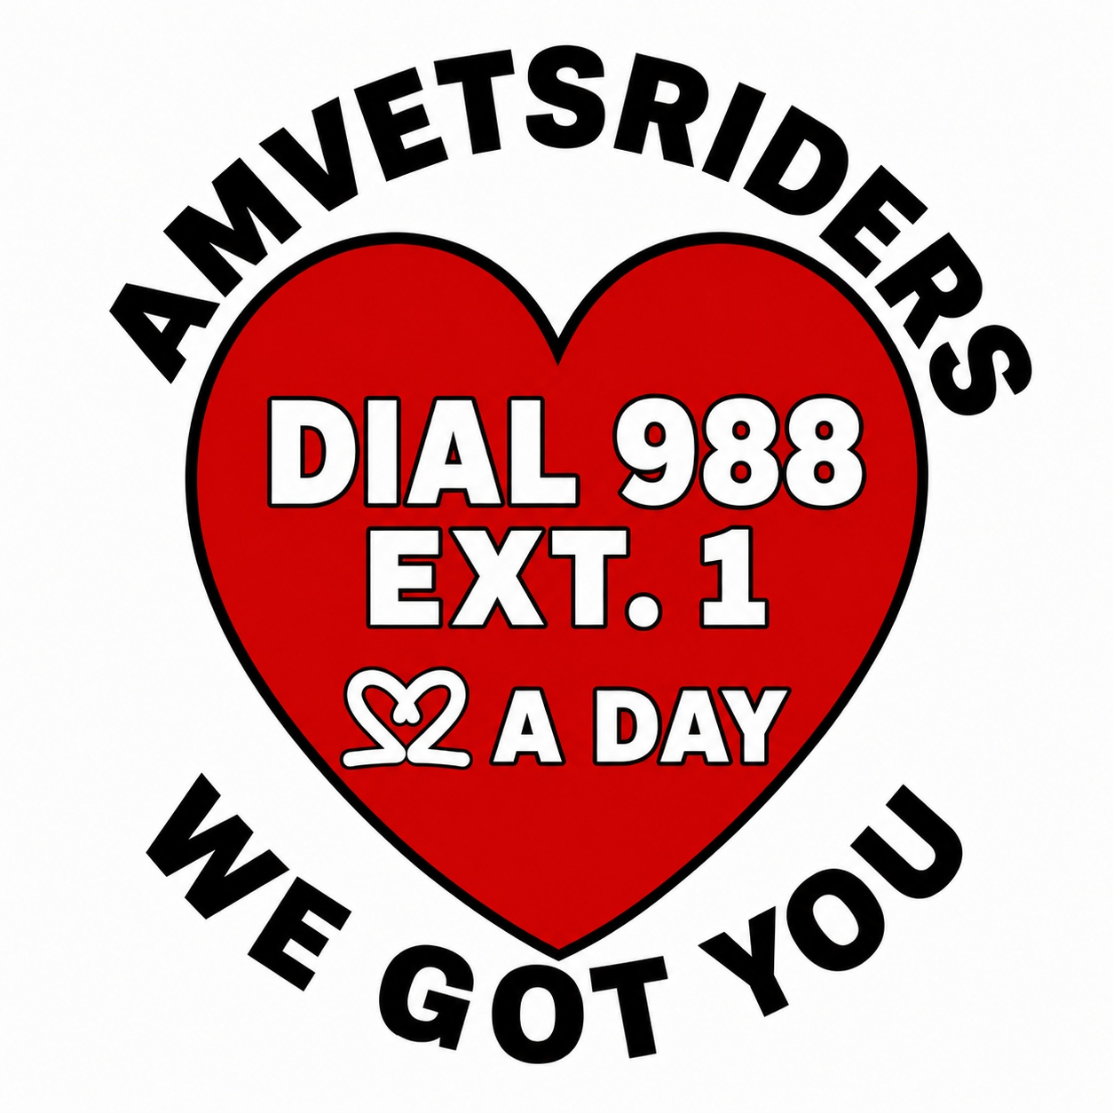
WE GOT YOU: Wallet Cards
Print on cardstock, cut along the dashed lines. Front (left) and back (right) of the same card.
WE GOT YOU  AMVETS Riders Veteran Wellness and Support  IN CRISIS? CALL  988  PRESS 1 | TEXT 838255  Veterans Crisis Line, available 24 hours a day |  | NEED HELP OR WORRIED ABOUT SOMEONE?  Chapter WE GOT YOU Contact:  _______________________________  Phone:  _______________________________  "No Wrong Door." We listen, share verified resources, and help you make the next call.    SCAN FOR RESOURCES
WE GOT YOU  AMVETS Riders Veteran Wellness and Support  IN CRISIS? CALL  988  PRESS 1 | TEXT 838255  Veterans Crisis Line, available 24 hours a day |  | NEED HELP OR WORRIED ABOUT SOMEONE?  Chapter WE GOT YOU Contact:  _______________________________  Phone:  _______________________________  "No Wrong Door." We listen, share verified resources, and help you make the next call.  SCAN FOR RESOURCES
WE GOT YOU  AMVETS Riders Veteran Wellness and Support  IN CRISIS? CALL  988  PRESS 1 | TEXT 838255  Veterans Crisis Line, available 24 hours a day |  | NEED HELP OR WORRIED ABOUT SOMEONE?  Chapter WE GOT YOU Contact:  _______________________________  Phone:  _______________________________  "No Wrong Door." We listen, share verified resources, and help you make the next call.  SCAN FOR RESOURCES
WE GOT YOU  AMVETS Riders Veteran Wellness and Support  IN CRISIS? CALL  988  PRESS 1 | TEXT 838255  Veterans Crisis Line, available 24 hours a day |  | NEED HELP OR WORRIED ABOUT SOMEONE?  Chapter WE GOT YOU Contact:  _______________________________  Phone:  _______________________________  "No Wrong Door." We listen, share verified resources, and help you make the next call.  SCAN FOR RESOURCES

WE GOT YOU: Local Resource Cards
Fill in your Chapter’s local resources once, then print and cut copies for volunteers and outreach events.
LOCAL RESOURCE CARD  VA Medical Center: _____________________  Vet Center: _____________________________  County Veterans Affairs / VSO: ______________  Transportation Resource: ___________________  Crisis: call 988, press 1; text 838255 |  | LOCAL RESOURCE CARD  VA Medical Center: _____________________  Vet Center: _____________________________  County Veterans Affairs / VSO: ______________  Transportation Resource: ___________________  Crisis: call 988, press 1; text 838255
LOCAL RESOURCE CARD  VA Medical Center: _____________________  Vet Center: _____________________________  County Veterans Affairs / VSO: ______________  Transportation Resource: ___________________  Crisis: call 988, press 1; text 838255 |  | LOCAL RESOURCE CARD  VA Medical Center: _____________________  Vet Center: _____________________________  County Veterans Affairs / VSO: ______________  Transportation Resource: ___________________  Crisis: call 988, press 1; text 838255
LOCAL RESOURCE CARD  VA Medical Center: _____________________  Vet Center: _____________________________  County Veterans Affairs / VSO: ______________  Transportation Resource: ___________________  Crisis: call 988, press 1; text 838255 |  | LOCAL RESOURCE CARD  VA Medical Center: _____________________  Vet Center: _____________________________  County Veterans Affairs / VSO: ______________  Transportation Resource: ___________________  Crisis: call 988, press 1; text 838255
LOCAL RESOURCE CARD  VA Medical Center: _____________________  Vet Center: _____________________________  County Veterans Affairs / VSO: ______________  Transportation Resource: ___________________  Crisis: call 988, press 1; text 838255 |  | LOCAL RESOURCE CARD  VA Medical Center: _____________________  Vet Center: _____________________________  County Veterans Affairs / VSO: ______________  Transportation Resource: ___________________  Crisis: call 988, press 1; text 838255

